**Calculator Assumed**

**Function Notation, Function Transformations, Domain and Range**

Time: 45 minutes

Total Marks: 45

Your Score: / 45



**Question One: [1, 1, 2, 2, 2, 2, 3 = 13 marks]**

Consider the following functions:



Calculate:

1. 
2. 
3. 
4. , giving your answer as an expression in simplified form
5. the value(s) of *w* for which 
6. the value(s) of *t* for which 
7. the equation of a new function, where 

**Question Two: [2, 3, 2, 3, 2, 2 =14 marks ]**

The function is drawn below.

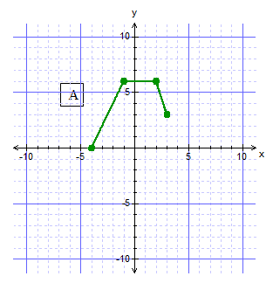

1. State the domain and range of the

function.

1.  is made up of three line

segments.

Determine the equation of segment A

and state its domain.

1. Determine the root of 
2. Sketch  and on the axes below, labeling your graphs.

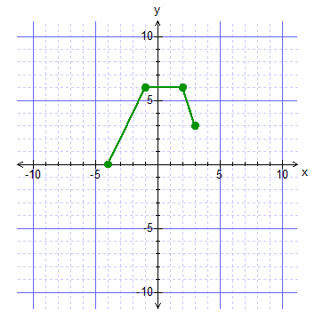

1. Describe the transformations that graph  to graph A, as shown on the axes below.

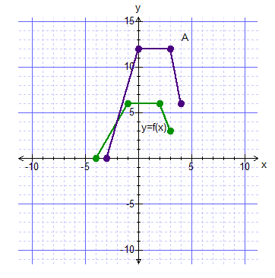

1. Sketch on the axes below.

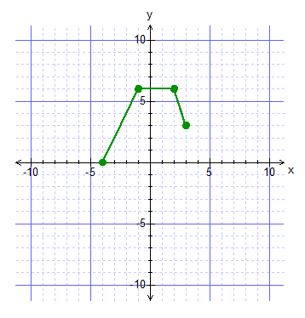

**Question Three: [4, 5, 5, 4 =18 marks]**

For each of the following graphs, determine the function equation and state the domain and range of each function graphed.

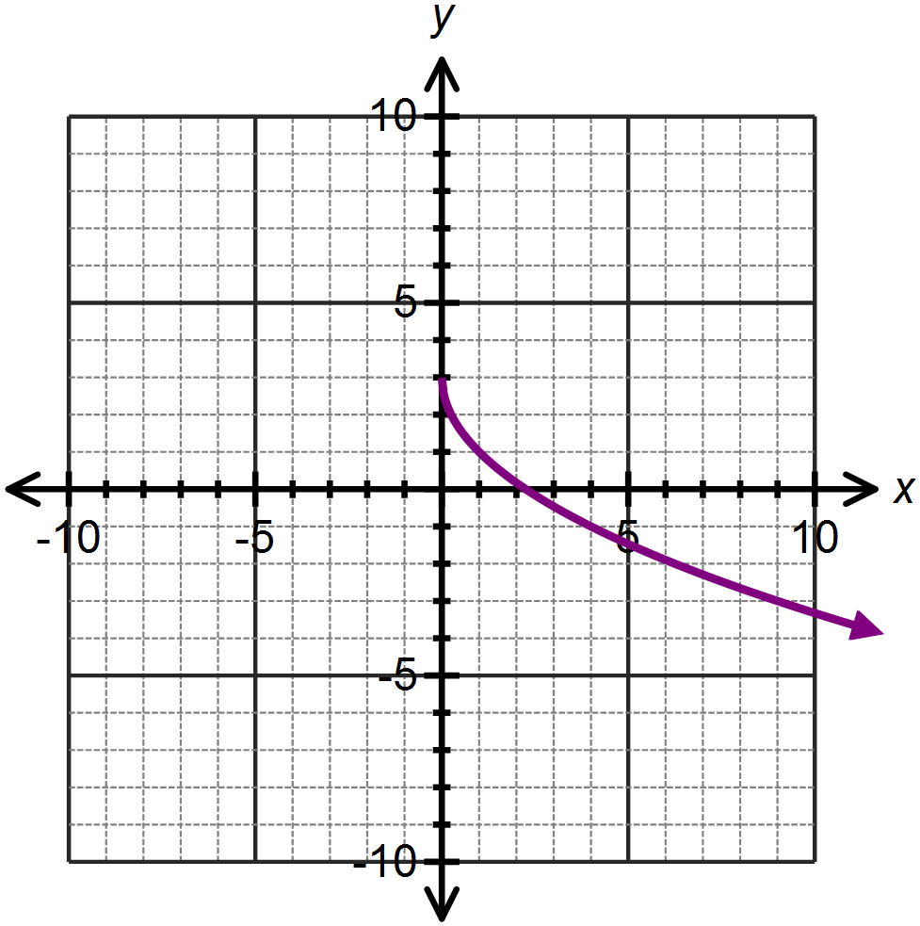

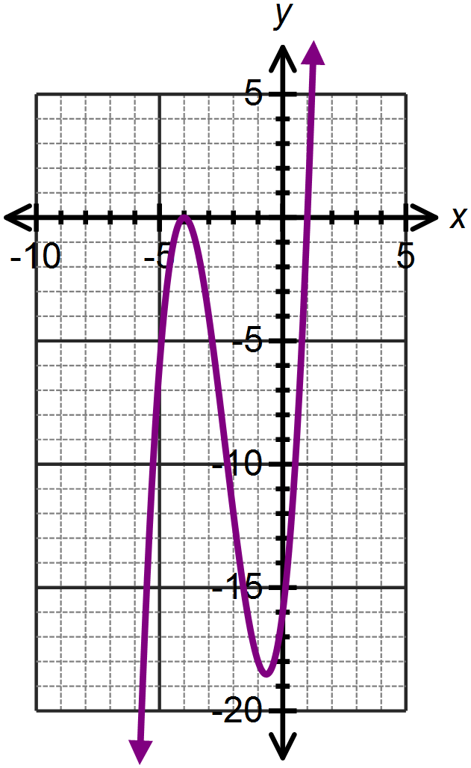

1. 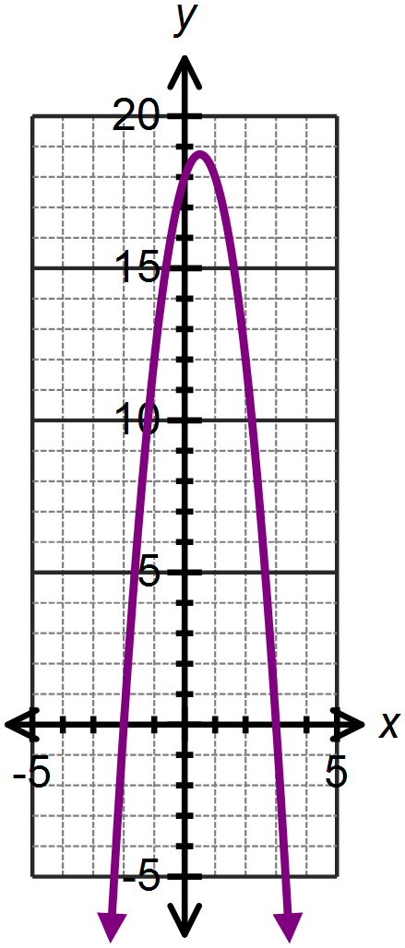

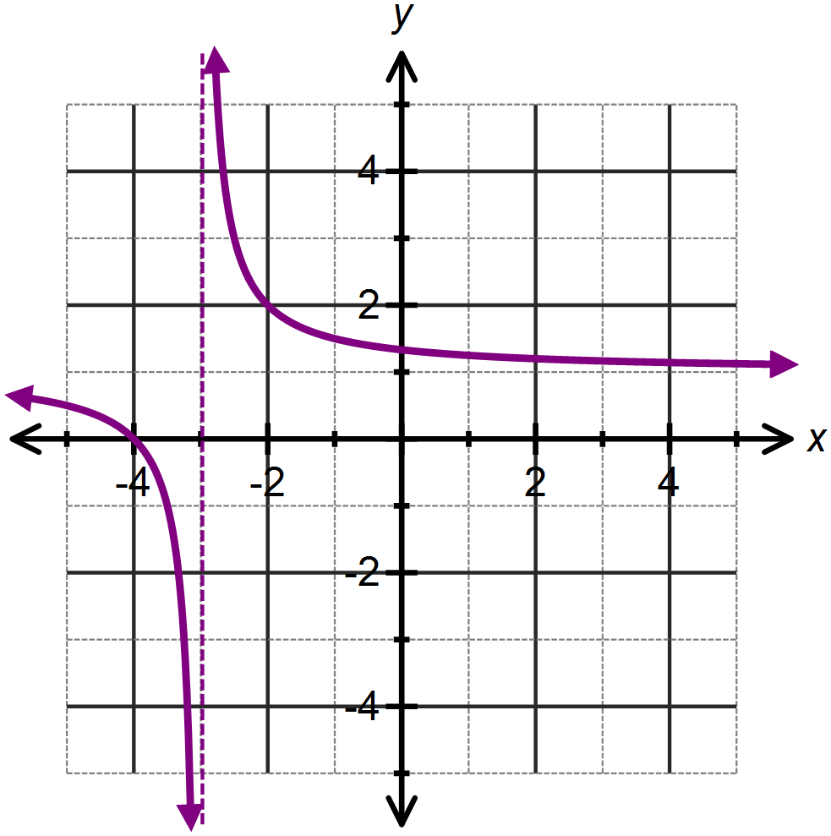

**SOLUTIONS**

**Calculator Assumed**

**Function Notation, Function Transformations, Domain and Range**

Time: 45 minutes

Total Marks: 45

Your Score: / 45



**Question One: [1, 1, 2, 2, 2, 2, 3 = 13 marks]**

Consider the following functions:



Calculate:



1.  



1.  
2.  
3. , giving your answer as an expression in simplified form



1. the value(s) of *w* for which 



1. the value(s) of *t* for which 





1. the equation of a new function, where 



**Question Two: [2, 3, 2, 3, 2, 2 =14 marks ]**



The function is drawn below.

1. State the domain and range of the

function.

A[Type a quote from the document or the summary of an interesting point. You can position the text box anywhere in the document. Use the Drawing Tools tab to change the formatting of the pull quote text box.]





1.  is made up of three line

segments.

Determine the equation of segment A

and state its domain.





1. Determine the root of 



1. Sketch  and on the axes below, labeling your graphs.



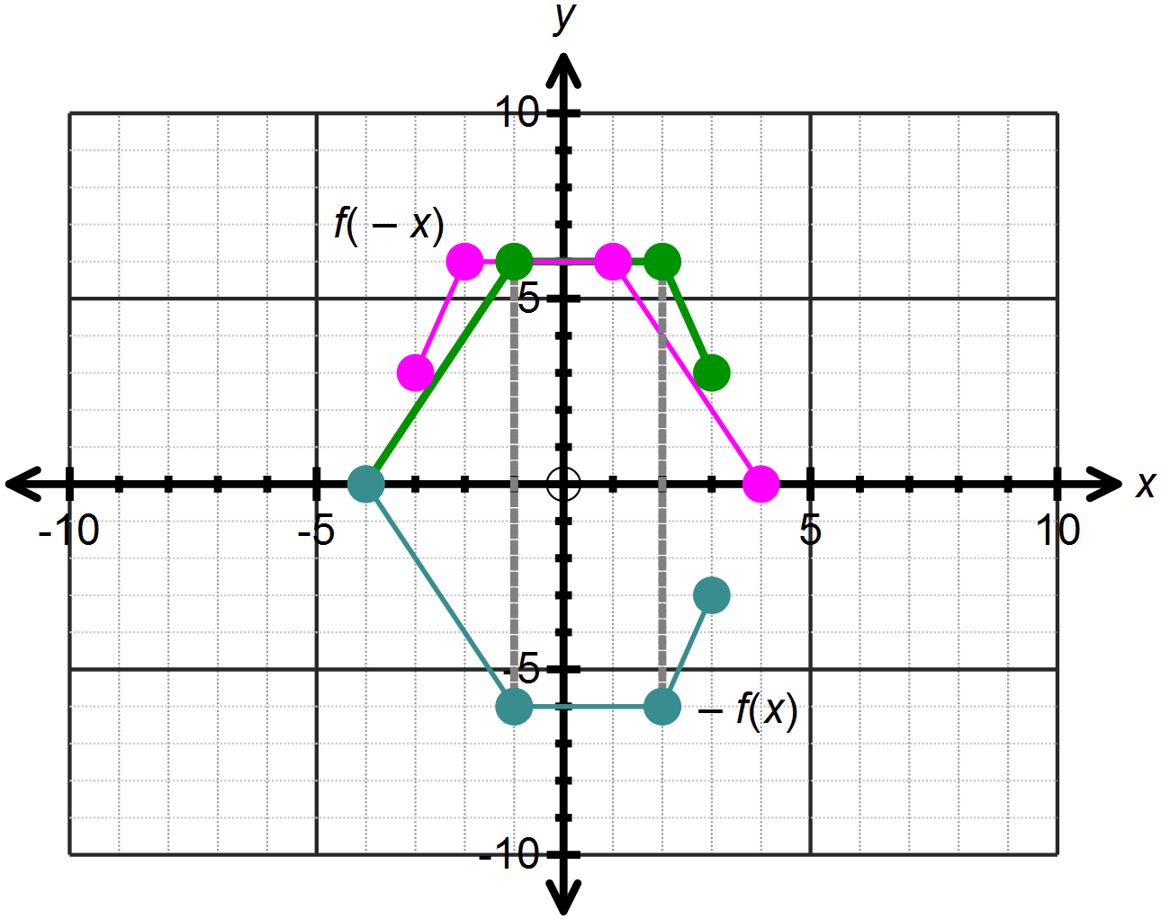Labels

1. Describe the transformations that graph  to graph A, as shown on the axes below.



Translate vertically 1 unit right

Dilate vertically scale factor 2



1. Sketch on the axes below.

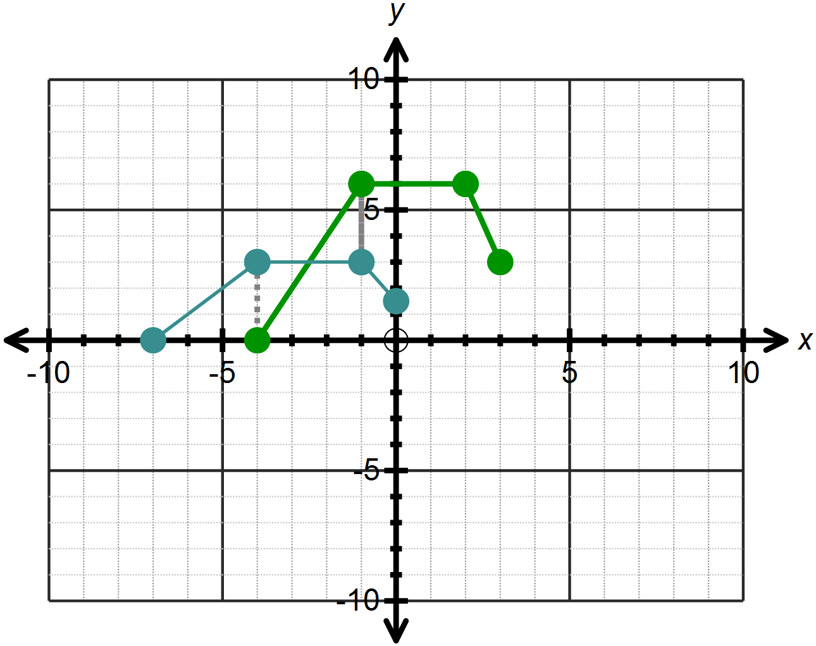

**Question Three: [4, 5, 5, 4 =18 marks]**

For each of the following graphs, determine the function equation and state the domain and range of each function graphed.















1. 











